Slack Quick Start Guide

Prepared for BCBS InterOpathon

Table of Contents

About This Document 1

Links to Helpful Videos & Webpages 1

About Slack 1

Sidebar 2

Channels 3

InterOpathon Channels 4

Message Input 5

Help Center 5

# About This Document

This Quick Start Guide has been prepared for the use of participants at the BCBS InterOpathon by Velatura. Please note this is not an official guide provided by Slack, useful materials from Slack are linked below.

# 

# About Slack

Slack is a collaboration site that will make it easy for event coordinators to share important information and answer questions. Your team will also be able to privately chat, share documents, and even call each other throughout the InterOpathon.

## Sidebar

Quick view of

* Channels available to you
* Notifications of new messages within those channels
* Direct messages with anyone who is attending the InterOpathon

1. **Compose -** write a message and if you do not send it right away, it will automatically save in the Drafts section of the sidebar.
2. **Channels -** messaging and file sharing that is only available to assigned users. For example, a general channel will be available to all participants of the InterOpathon to read and post messages, but your team will have an exclusive channel.
3. **Notifications -** red circles with a number of unread chat within the channel. When new messages are sent in a channel, it will alert the user via a text box that appears at the top of the channel. It is important that if you use Slack to allow the **Desktop Notifications**, this will allow you to receive notifications outside of Slack!
4. **Direct Messages** - one-on-one chats with anyone present at the event, including event coordinators.

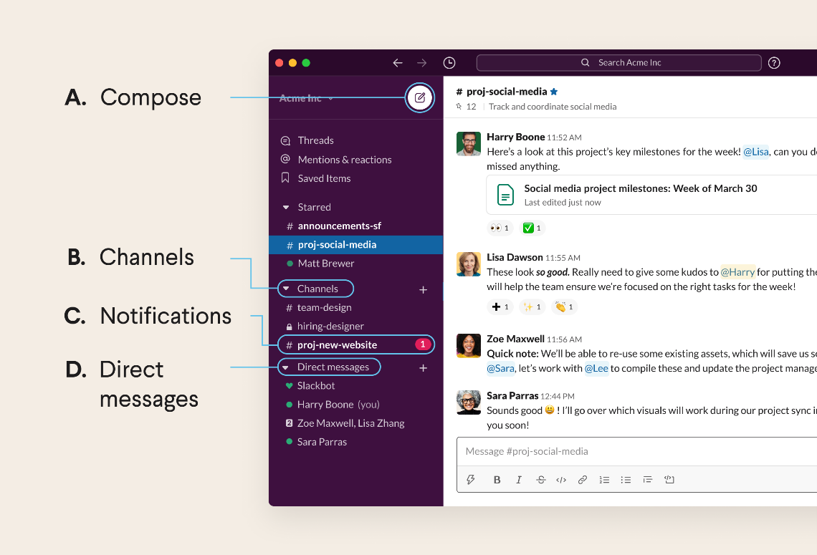

## Channels

Channels are the fundamental work spaces in Slack and allow you to easily reference materials from the event coordinators and work privately with your team.

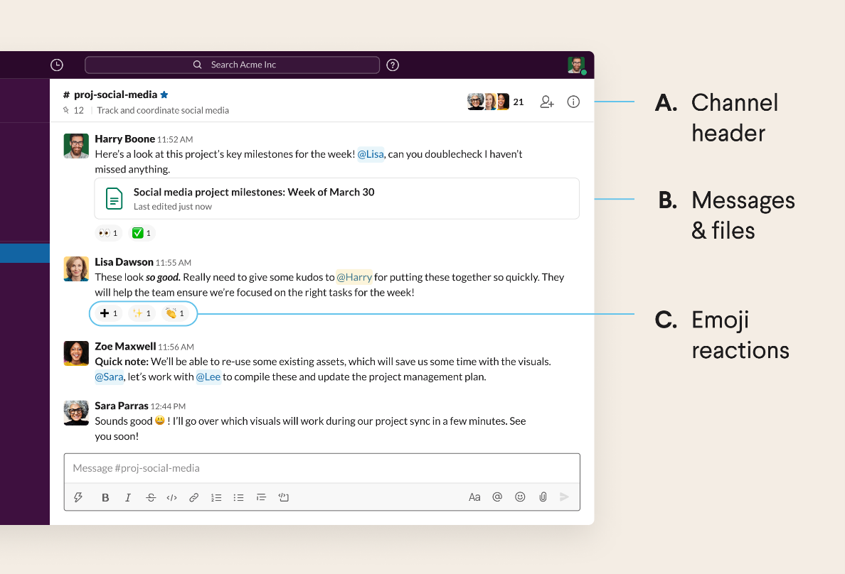

1. **Channel Header** - overview of the channel that includes who has access, a brief description, and any other important channel information. This can be seen at the top of the message list or by clicking the i icon on the top right.
2. **Messages & Files -** send and read messages & files from others who have access to the channel. If you include @[team member’s name], that team member will get a special notification alerting them to the message.
3. **Emoji Reactions -** quickly respond to a message with a smiley face or a thumbs up, to let others know you saw the message without having to type an entire reply.

### InterOpathon Channels

**#team #:** This will be your team’s private work space. Here you can communicate openly and freely without worry of other team’s seeing your work. You can also utilize Slack’s video calling features if needed. The only people who are able to see a team channel, are the team members and Event Coordinators. Each team will be assigned a number prior to the start of the event, this will correlate with your team space.

**#general:** This channel will be the main point for announcements within the Slack group. Here event coordinators will provide event updates, bonus challenge winners, and any important communications.

**#use case:** Each of the use cases available during an InterOpathon will have their own help channel. These channels are available so participants can reach out to Use Case experts to ask questions and are not made for technical questions, but for content related questions. During the event, you will find CDex, PDex, and Carin-BB channels that will be populated with Subject Matter Experts.

**#help-desk:** This channel is for technical help, namely Interoperability Land (IOL) related help. Here IOL specialists will be available to help identify and solve IOL related problems.

**#random:** This channel is simply for participants to talk about anything they’d like, so long as it is work appropriate

**#submissions:** This channel is for teams to submit any final documents and demos needed at the end of the event. It is open to all teams and will be available for them to submit things as needed. Submissions sent here will be viewable by everyone, but are only submitted once the working period has closed.

## Message Input

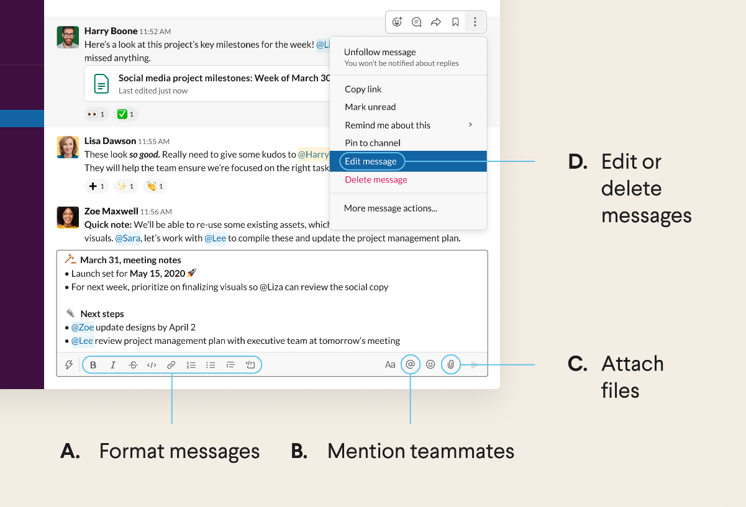You can contribute to the channels by writing messages, sharing files, and mentioning your teammates.

1. **Format Messages** - change the appearance and structure of your messages to add clarity by using the tool bar at the bottom.
2. **Mention Teammates** - @[team member’s name] to quickly alert team members of updates or action items to the appropriate user. Click the @ button at the bottom or type it in.
3. **Attach Files -** share files in messages directly from your computer or from cloud based services by clicking the paper clip in bottom right corner.
4. **Edit or Delete Messages -** edit mistakes after you’ve sent a message or delete it and start fresh by right clicking the message.

## Help Center

You can access the help menu to find any additional resources and navigate some of the more complicated features of Slack. The Help Center can be found on the Slack website by using the following link: <https://slack.com/help>